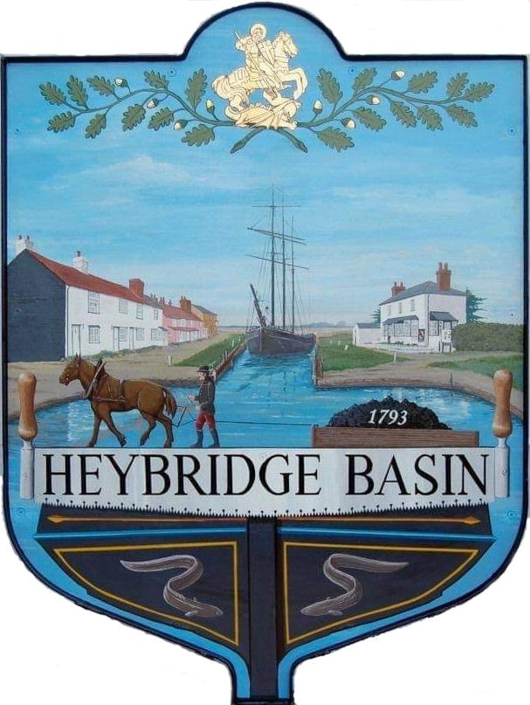

HEYBRIDGE BASIN PARISH COUNCIL

Minutes of the Full Council meeting of Heybridge Basin Parish Council held on Tuesday 13th February 2024 at 18.30pm, at The Lock Tea Room.

PRESENT

In the Chair: M. Hodges (Chair) Absent: 0

Councillors: R. Bryson Apologies: 2
C. Edmond
M. Hobden Public: 1
S. Sjollema
District Councillors: N. Spenceley
Officers: G. Lake – Clerk

It was noted that this meeting was being recorded by the Clerk.

23/176 Chair’s Welcome
Cllr Hodges welcomed everyone to the meeting and thanked District Councillor Paula Spenceley for taking the time to host the two extraordinary meetings regarding the St Peters Consultation. It was agreed for the Clerk to write a formal letter of thanks.

23/177 Apologies for Absence.
Cllrs Howat and Swann.

23/178 To receive Declarations of Interest in accordance with the Council’s Code of Conduct and with section 106 of the Local Government Finance Act 1992.
C. Edmond – Non-Pecuniary – Essex Waterways and Director of Cloughton Court Management Company Ltd and Cllr Hobden – Non-Pecuniary – HBSA, Basin Oars and HB Rivercare.

23/179 To sign as a correct record the minutes of the full council meeting held on 16th January 2024.
The Minutes as previously circulated were agreed as a correct record.

23/180 To sign as a correct record the minutes of the extraordinary meeting held on 5th February 2024.
The Minutes as previously circulated were agreed as a correct record.

23/181 To sign as a correct record the minutes of the extraordinary meeting held on 6th February 2024.
The Minutes as previously circulated were agreed as a correct record.

23/182 To receive a report from the District and County Councillors for the area on any matters of interest.
A report was received from the District Councillors. There were no reports from County Councillors.

23/183 Finance.
- To approve
- Payment requests for January/February 2024.
The Payments as previously circulated were approved.
- Receipts for January/February 2024.
The receipts as previously circulated were approved.
It was noted that a donation from a resident was received towards the car park, therefore it was resolved to transfer the donation into the DMCP bank account and put the money towards planting in the raised bed.

23/184 Risk Assessment
  - To review the Risk Assessment and agree any action to be taken.
The amendments to the Risk Assessment were approved.

23/185 Public Forum
No members of public wished to speak.

23/186 Planning Applications
- To consider any planning applications received after the publication of the agenda and to agree the action to be taken.
There were no planning applications.

23/187 St Peters Community Hospital
- To consider organising timed slots to help residents with the consultation survey and agree any action to be taken.
It was resolved to organise timed slots at St George’s Community Room with dates and times to be organised via email between members and the Clerk.
  - To consider and agree creating and circulating a flyer to post to all residents with information relating to the consultation.
It was resolved for the Clerk to create a flyer including information on what the consultation is about, how to access the survey and information on the Councillor Surgery dates and how to book.

23/188 Daisy Meadow Car Park (DMCP)
- To review the access road design and specification and agree any action to be taken.
The access road design was approved with amendments which included the removal of the 10mph signs as well as adding 2 speedbumps. It was resolved for the Clerk to send the amended design to the 13 contractors who had previously submitted a quote, along with a questionnaire created by the WG. It was resolved for the contractors to submit their amended proposal to the Clerk via email by 29th February. It was resolved for the WG to meet on 1st March and discuss the proposals, and whittle down to an appropriate number to bring to the full council for consideration, however if all 13 proposals are received before the 29th February, the WG can arrange to meet before 1st March. It was agreed to pencil in an EGM date of 1st March with a view of amending if not all councillors can attend.
- To receive an update from the Working Group and agree any action to be taken.
It was noted that there were no conditions to remove the Laurels and Conifers, there were confusions with the consulted tree officer report. Clerk confirmed that the Laurels and Conifers are being felled on 28th and 29th February and that the Rohan House Survey is booked for 27th February.
It was resolved to allow DFL Clark to do a trial dig and expose the services by the tree stumps as there would be no cost to the Council.
The WG reported concerns over the flooding which happens within the car park, the Council resolved for HRS Marine Services to clear the pipe at a cost of £100. It was noted that the Council would only need to pay if this fixed the problem.
It was resolved to keep the car park tariff, residents, and tearoom parking concessions the same and to review again later in the year.

23/189 20’s Plenty
- To receive an update from Cllr Sjollema and agree any action to be taken.
An update was received. It was resolved for Cllr Sjollema to contact Cllr M. Durham.
23/190 Heritage Trust
- To consider and agree for Cllr Howat to complete a survey being circulated by the Heritage Trust Network on behalf of the PC.
It was resolved to defer this item to a future meeting attended by Cllr Howat.

23/191 Turning Post
  - To receive an update from Cllr Edmond regarding ownership of the post and agree any action to be taken.
Cllr Edmond circulated a Licence Agreement from Essex Waterways. It was resolved that members would review the document with the draft policy.
  - To discuss the draft policy and agree any action to be taken.
It was resolved for members to consider an application criterion and email their suggestions to Cllr Hobden to review at the next meeting.

23/192 D-Day 80
- To receive an update from the Working Group and agree any action to be taken.
The WG had met, and its members were tasked with various research actions.

Cllr Sjollema left at 19:41pm

It was resolved that the Council would host an event on Thursday 6th June 2024 starting at around 4pm with the beacon being lit at 09:15pm. It was resolved for the Clerk to purchase 200 waving union jack flags at a cost of £31.72.

23/193 Clerks Report
  - Clerks Working Hours – It was noted that the Clerk would not be working from Monday 19th February to Friday 23rd February due to the school half term.
  - Hedges along Basin Road – It was noted that there had been no response since the Clerk wrote to the owners, and that no action had been taken. It was recommended that Cllr Bryson re-visit the owners to discuss how urgent the work was and how close it is to nesting season.

23/194 Correspondence
- To note correspondence received and any actions to be taken.
Correspondence was noted and responses were agreed.
It was resolved to allow Farleigh Hospice to use the car park for their event on Sunday 12th May 2024 and to allow up to 10 volunteers the use of the car park free of charge.

23/195 Pursuant to section 1(2) of the Public Bodies (Admission to Meetings) Act 1960 it is resolved that, in view of the confidential nature of the business about to be transacted, it is advisable in the public interest that the press and the public be excluded, and they are instructed to withdraw.

Members of the public left.

23/196 DMCP
- To consider an enquiry and agree any action to be taken.
The enquiry was considered, and it was resolved for Cllr Hodges to draft a response to send to the Clerk.

There being no further business the meeting closed at 08:55pm
Provisional Date of the next Council Meeting Tuesday 12th March 2024

Clerk Contact details: clerk@heybridgebasinpc.org.uk
Website: www.heybridgebasin-pc.gov.uk

